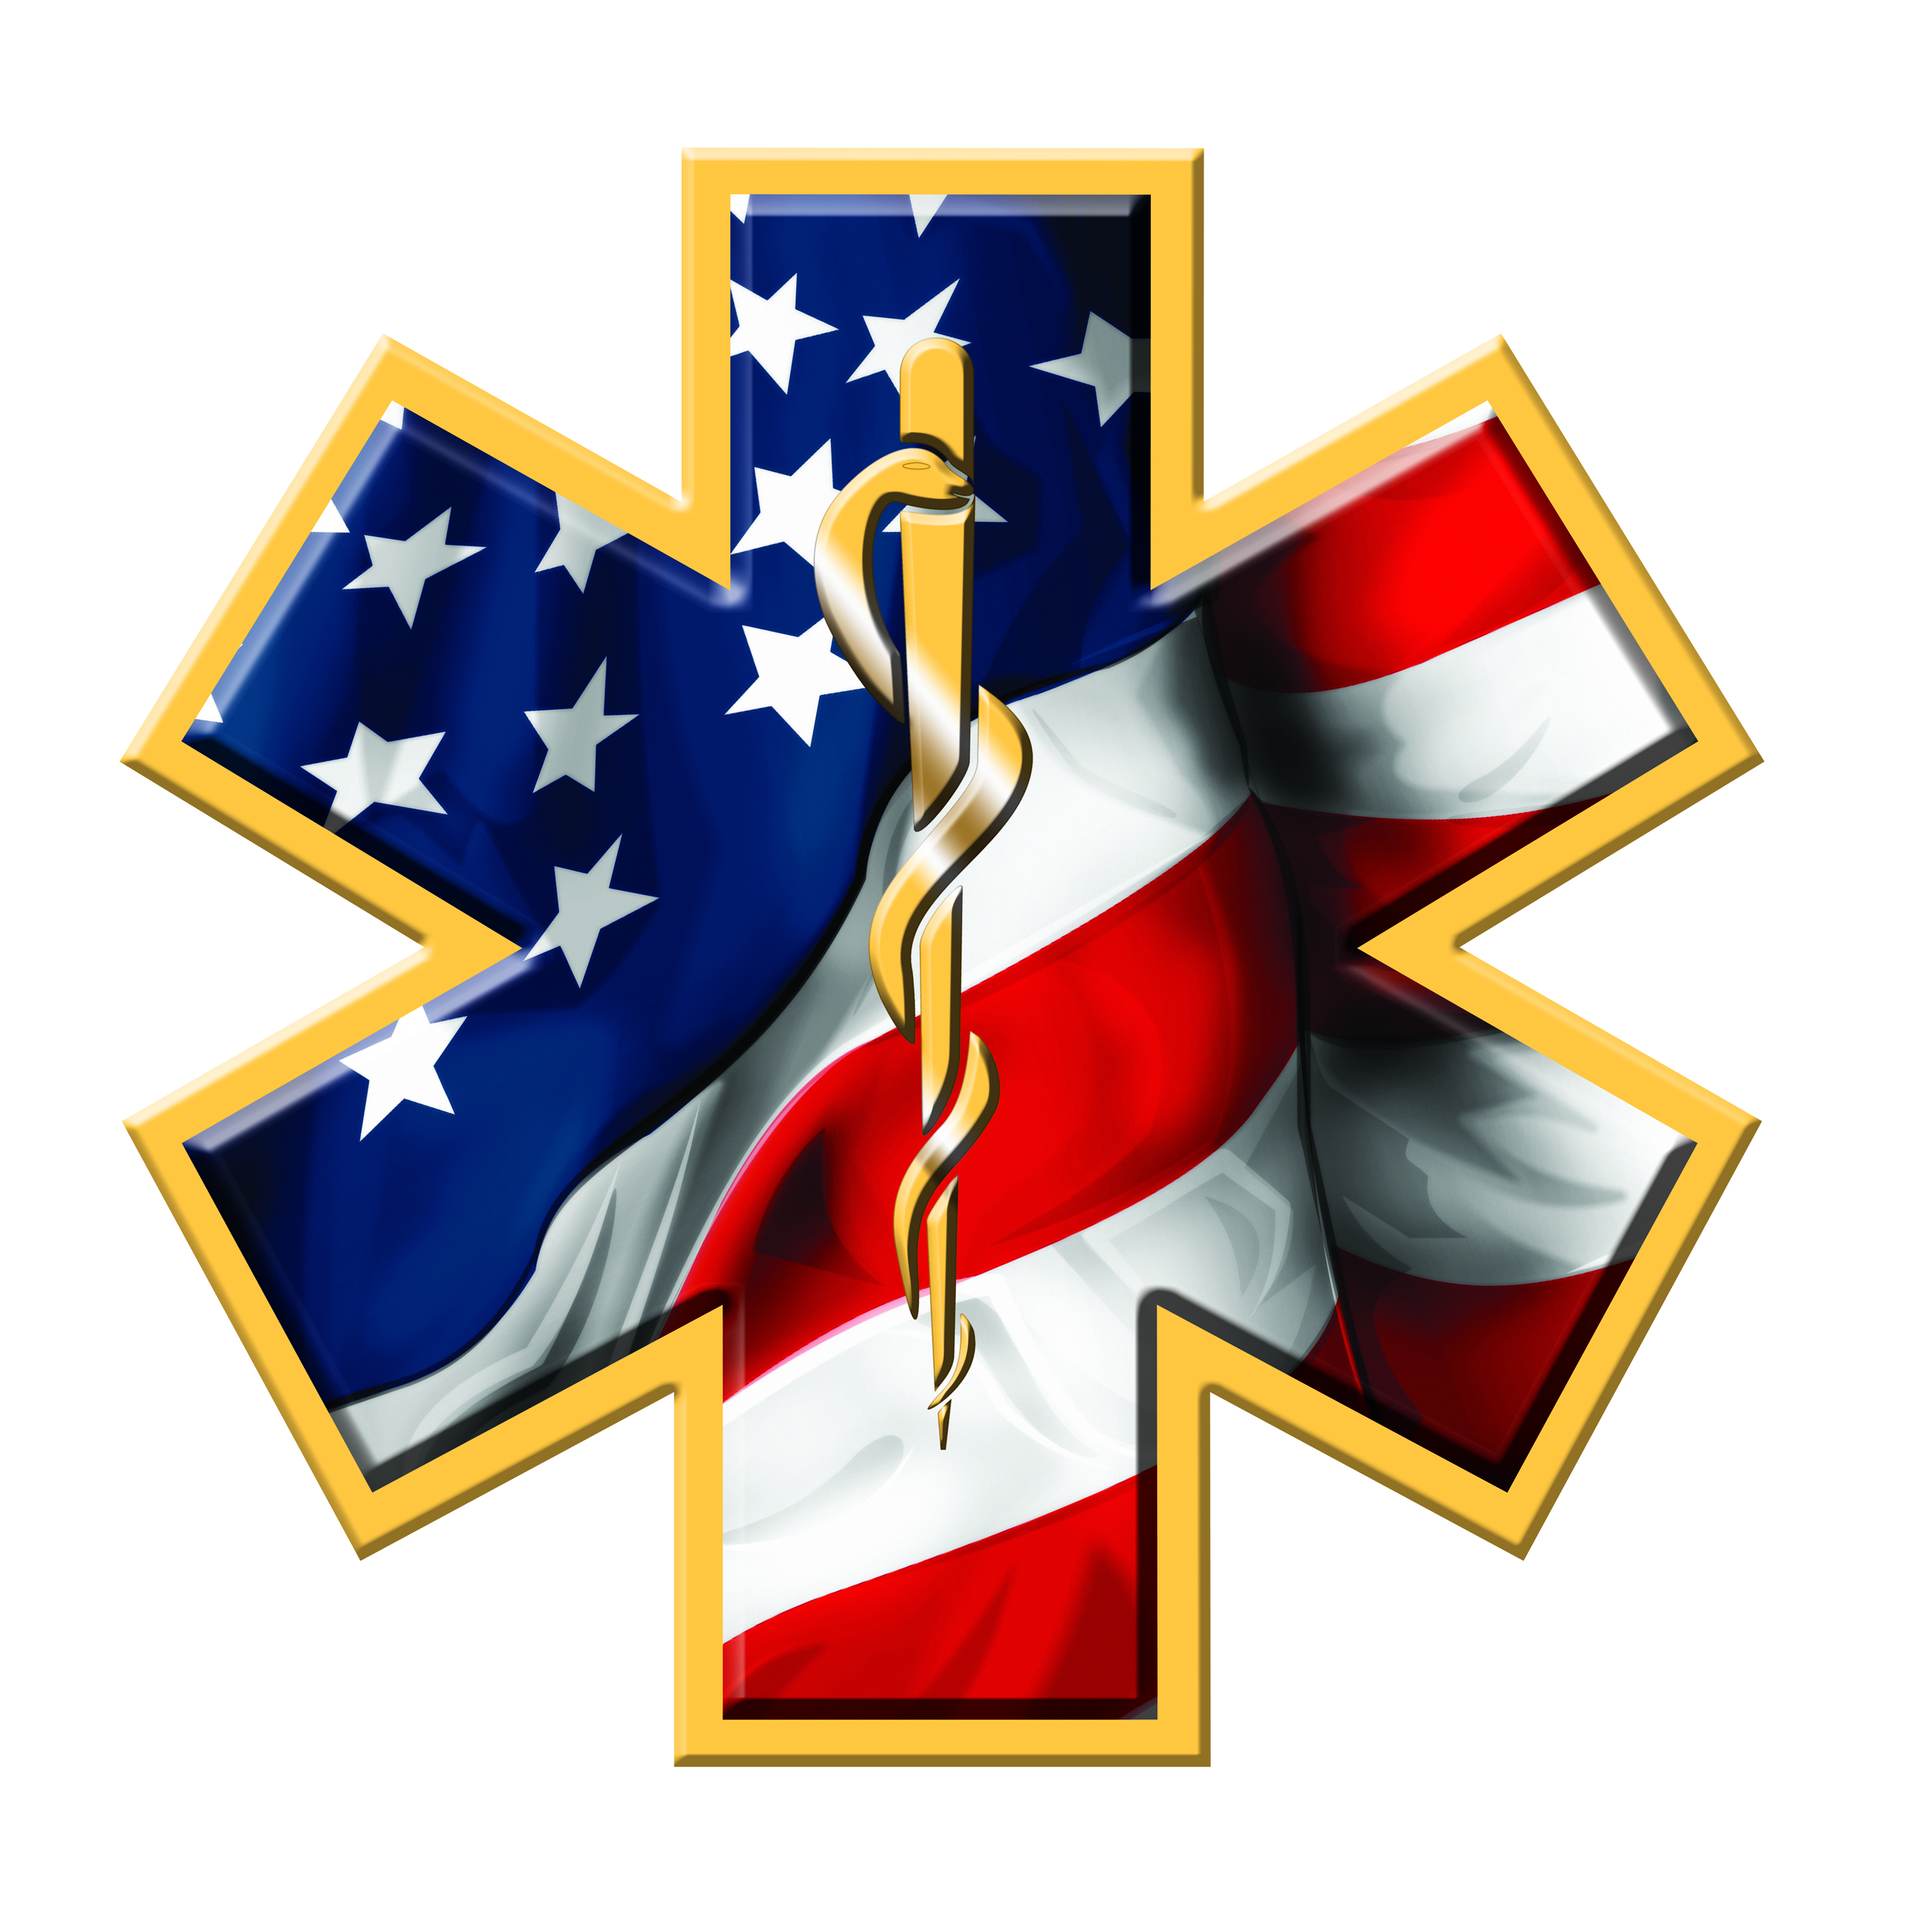

Marion County Ambulance District

142 Jaycee Drive

Hannibal, Missouri 63401

Phone (573)221-5510 Fax (573)221-5004

August 14, 2024, 1:45 P.M.

Notice is hereby given that Marion County Ambulance District will conduct a board meeting at 6:00 p.m. on Thursday, August 15, 2024, at the Administration Building located at 142 Jaycee Drive, Hannibal, Missouri.

The tentative agenda of this meeting includes:

1. Call to order
2. Public Hearing
3. Approval of minutes of regular meeting held on July 18, 2024.
4. Review reports for July 2024.
5. Chief’s Report
6. Old Business
7. Tourism Center
8. New Business
9. Set Tax Rate for 2025
10. Audit
11. Adjourn

Representatives of the news media may obtain copies of this notice by contacting:

John Nemes

142 Jaycee Drive

Hannibal, MO 63401

573-221-5510